**Order Form**



**Nama Perusahaan Kaos**

|  |  |  |
| --- | --- | --- |
| 0270 1234 1234 | Jl. Nama Jalan No. 123 Nama Daerah, Nama Kota  Nama Provinsi | namaperusahaankaos.com |

|  |  |  |  |
| --- | --- | --- | --- |
| ORDER INFORMATION | | CUSTOMER INFORMAION | |
| Order No. |  | Nama |  |
| Tanggal Order |  | Alamat |  |
| Tanggal Jadi |  | No. Telp/Email |  |

|  |  |  |
| --- | --- | --- |
| Size | Qty | Warna |
| ▢ Anak |  |  |
| ▢ XS |  |  |
| ▢ S |  |  |
| ▢ M |  |  |
| ▢ L |  |  |
| ▢ XL |  |  |
| ▢ XXL |  |  |

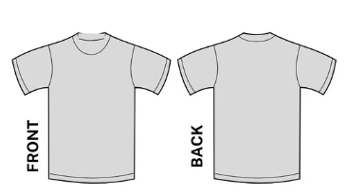

|  |  |  |
| --- | --- | --- |
| ▢ Lengan Pendek | ▢ 100% Cotton | ▢ Unisex |
| ▢ Lengan Panjang | ▢ Poly Blend | ▢ Wanita |
| ▢ Saku | ▢ Sweatshirt | ▢ Hoodie |

|  |  |
| --- | --- |
| Subtotal |  |
| Diskon |  |
| Pajak |  |
| Total |  |

|  |  |  |
| --- | --- | --- |
| Metode Pembayaran | | |
| ▢ Cash | ▢ Debit | ▢ Credit |

|  |
| --- |
| Catatan: |

|  |  |  |
| --- | --- | --- |
| Metode Penyerahan | | |
| ▢ Pick Up | ▢ Drop Off | ▢ Pengiriman |

|  |  |
| --- | --- |
| Tanggal Pengiriman |  |
| No. Resi |  |